Lab 2:

**Task 2.1: Light on/off system (2.5 points).**

**Part 1:**

# 

**Part 2:**

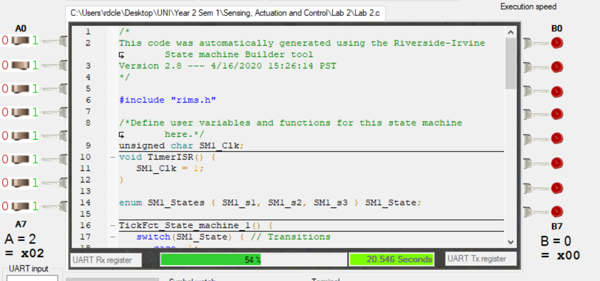

**Task 2.2: Card Speed Detector using synchSM (2.5 points)**

**Part 1:**

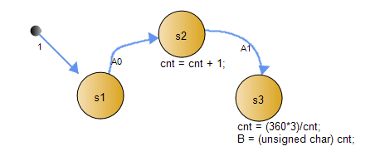

**Part 2:**

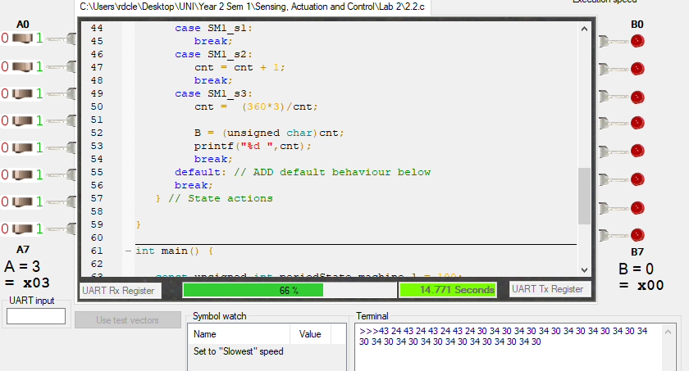

**Task 2.3: Fuel-level sensor (5 points).**

**Part 1:**

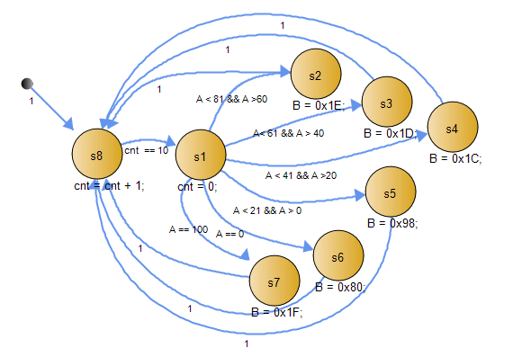

**Part 2:**

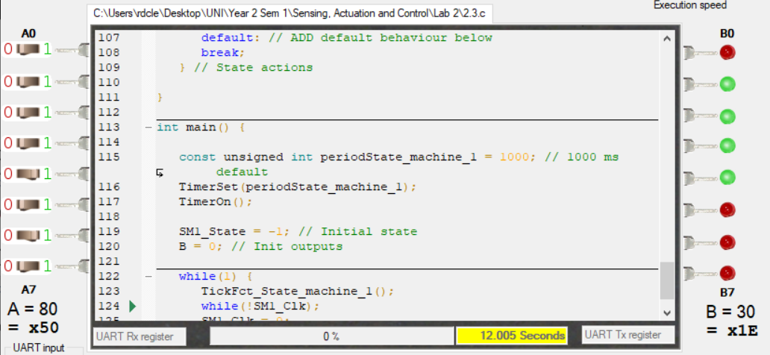

**Task 2.4: Portable electric heater using multiple tasks and a shared**

**variable (5 points).**

**Part 1:**

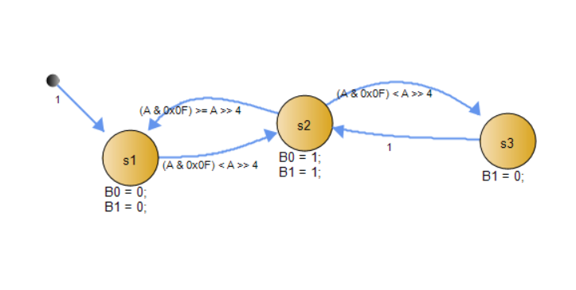

**Part 2:**

